**The Twitter Scenario**

A Wardley Mapping Exercise

### Who Are You?

You are a member of the executive board of a holding company for several large, well-known media brands. In an alternate universe, Twitter never became a publicly-traded company. Instead, a few years ago it was bought by your company, a multinational conglomerate, and now operates as a subsidiary. You’re attending a meeting of the Twitter executive team. As a member of your executive board, you’re trying to figure out what to do with Twitter.

Lately, the press have been reporting positively about Twitter’s growth and ability to push through hard times. Analysts are giving it a thumbs up this year and there is even some interest from third parties in acquisition. Twitter has a single product which is a publishing platform and social network.

The CEO introduces the company and their vision to give users valuable, relevant, global news, entertainment, and social interactions using the best content sharing platform available. The CEO describes their mission to help people connect with the events, brands, and people who shape their lives. She reiterates their core values in a presentation. The values are described as instrumental to the company’s success and they include responsibility, integrity, transparency, compassion, empathy, adaptiveness, and decisiveness. She then begins to give you some background on the product itself.

### What Is Twitter?

Twitter is a proprietary publishing and media distribution platform. In the Twitter ecosystem, the unit of content through which media is distributed is a single, published post called a “tweet”. The product experience is supported by a mixture of custom data center operations, cloud infrastructure, big data platforms, high-performance compute and streaming data platforms, messaging, and a content delivery network which presents content to users through native mobile, desktop, and TV apps, and also websites.

The architecture and software patterns for the end-user applications are based on a decade of best practice for customer-facing systems, but the platform underlying Twitter’s user experience is in constant flux as the team attempts to meet the unique scaling requirements of distributing 500 million posts to 300 million monthly active users (MAU).

The system also contains a learning AI which develops content recommendations and suggestions for accounts to follow, based on their interests. The AI is also responsible for identifying short-lived content trends so that users can follow breaking stories and hot topics. Additionally, the AI develops user interest profiles that are used by the advertising platform in order to allow marketers to filter Twitter’s extensive user base to target their messages at specific groups who are likely to respond positively to their ads.

At its core, Twitter is a publishing platform aimed at the general public. It is a way for people to read and share content that is important to them. Its focus is on real-time events, short thoughts, and brief conversations. Increasingly, Twitter is being used as a way to engage with global news and events published by the popular press, journalists, marketers, and other media outlets. Twitter has provided a platform for advertisers for several years now with the concept of “promoted content” that appears embedded within content streams. The advertising side of the business is responsible for a majority of Twitter’s revenue. Additionally for developers, Twitter offers paid subscriptions to the gamut of streaming content published on its platform.

You note that the group is clearly proud of their accomplishments, the technological marvel they have created, and their ability to deliver against their vision. Next up to speak is the Chief Marketing Officer.

### Marketing and Business Development

While Twitter began as a way for users to post simple status updates in 2006, it has matured into a powerhouse of news media distribution and brand marketing. To that end, the Twitter branding and marketing materials clearly reflect the techno-optimism that originally drew users to the product in the beginning. This is layered on top of a clean, unified style, clear voice, and a simple interface designed to encourage adoption and to instill confidence as a trustworthy means of having conversations around breaking news.

In terms of competition for user attention in the social media space, as of Q1 2019, the company is the 14th largest virtual community in the world by number of active users, and 9th largest in the United States behind Facebook, YouTube, WhatsApp, Messenger, Instagram, iMessage, LinkedIn, and Tumblr. It is followed closely by Reddit and Snapchat.

Although Twitter has competition from companies in China—and is also conveniently blocked from the internet in China—these companies have yet to see much mainstream adoption in the U.S. Further, Tencent’s WeChat app, at 1 billion users, is not just a media platform but an interlinked series of diverse businesses that are unified by a mobile experience. The CMO believes this lack of focus will be a barrier to adoption in the U.S. The heads of product and sales nod in agreement. The CMO also notes that a large portion of their growth as of late can be attributed to an uptick in interest in U.S. politics that began with the presidential election in 2016. Political news on Twitter continued to grow with the midterm elections in 2018. The site is the number one social network for governments and politicians, and 71% of Twitter users read news on the site.

To capitalize on the growing interest in political news and events, an aggressive sales and marketing plan has been developed to increase its daily active user (DAU) growth rate from 9% YoY in 2018 to 15% YoY in 2020, betting on a huge surge in usage that should accompany the next presidential election. All of that said, they note that 80% of their user base is outside of the U.S., and although analysts predict that the U.S. user growth rate will be closer to 1% in 2019, the team is dedicated and ready to work hard to increase U.S. market share.

In global markets outside of China and Europe, social networks continue to increase in usage as internet and mobile connectivity increase. There are advances in the Middle East, Africa, Latin America, South Asia, and Southeast Asia. The Middle East, in particular, has seen enormous growth since the Arab Spring uprising in 2011. Although the U.S. market is larger and considered to be more mature, there are incentives to encourage growth in these markets. The head of strategy notes, “These are highly attractive future markets and ones the company plans to exploit.”

Everyone acknowledges with a laugh that the elephant in the room is Facebook, which dominates the social media space with almost 2.5 billion users worldwide, not including users for its subsidiary companies, WhatsApp, Messenger, and Instagram, all of which individually have more active users than Twitter. At this point, the Chief Information Officer also raises the specter of social gaming and esports, the popularity of which has started to grow exponentially, especially with younger adults. “Amazon, for example, has been investing heavily in gaming for years now. And we mustn’t discount the sudden rise of games like Fortnite and Apex Legends,” she says. You notice the tension in the room as the CEO states that this is ground they’ve covered before. “For now,” the CEO says, “we’ve determined that these other platforms are not a direct threat, and in fact, we plan to look into addressing the gaming market as part of our strategic plan later this year.”

### 

### Sales

The head of sales takes over the presentation and starts to run through the growth of the company. It’s obvious that there’s a lot of coordination between marketing, sales, and product, and this team seems to be working well together.

Twitter became profitable for the first time in Q4 of 2017. In 2018, the company posted record revenue of $3B, up from $2.4B in 2017.

*Figure 1 – Revenue growth*

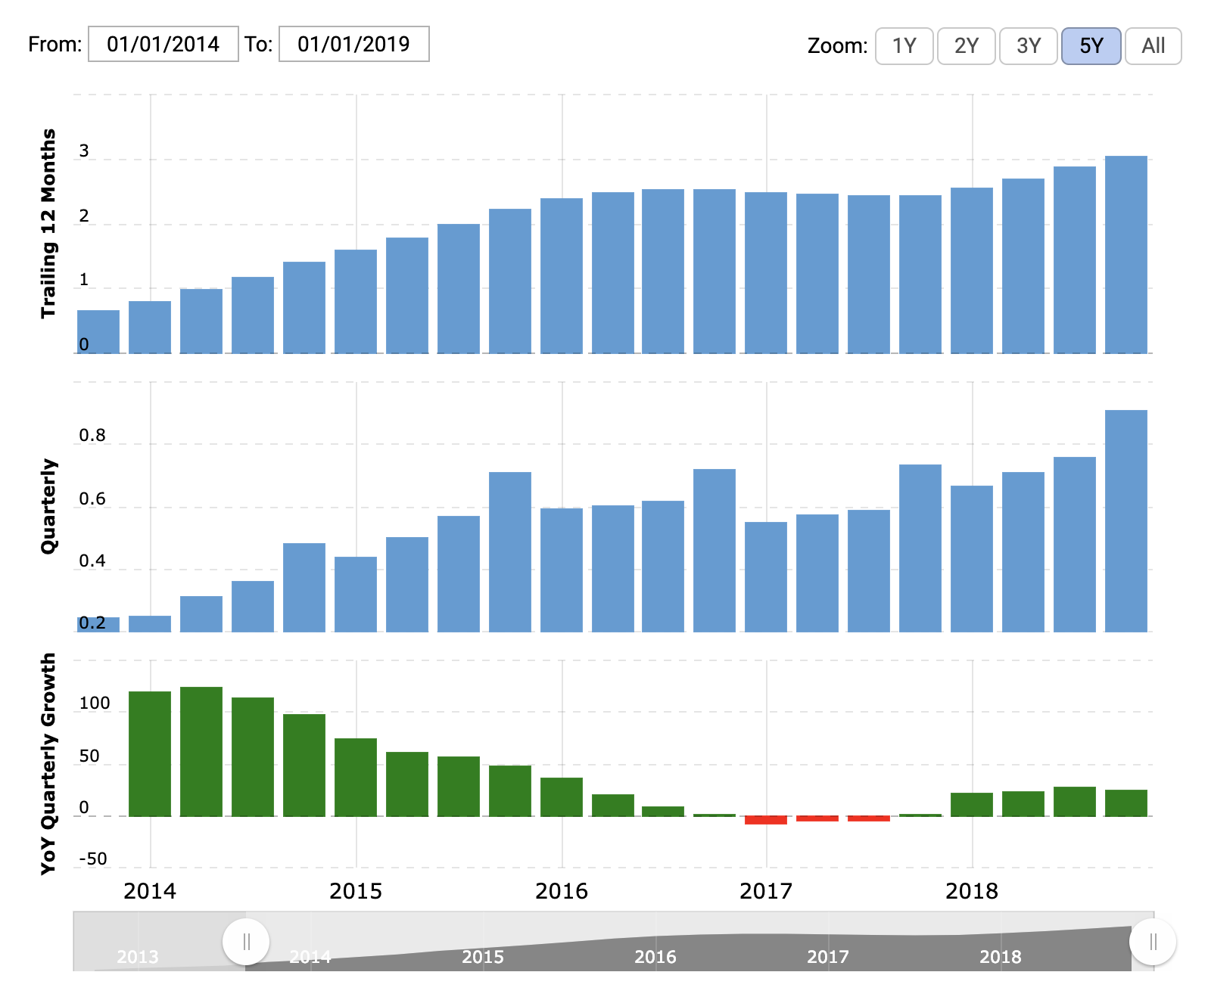*Copyright 2019 Macrotrends LLC*

MAU showed a decline from 330M users in 2017 to 321M in 2018. Although the growth curve of the user base appears to have peaked, the team believes this is mostly due to recent internal efforts to control the rise of fake, bot, and spam accounts that have plagued the site for years. On this front, the team is especially proud of their efforts to reduce the amount of abuse that is reported by regular users, and a concentration on identifying and removing these problem accounts over the last year has been a big part of that effort. It is believed that abusive accounts have been one of the primary barriers to growth, user satisfaction, and continued usage. The team expects 2019 to be marked by a turnaround in these areas.

*Figure 2 – Monthly Active Users (MAU)*

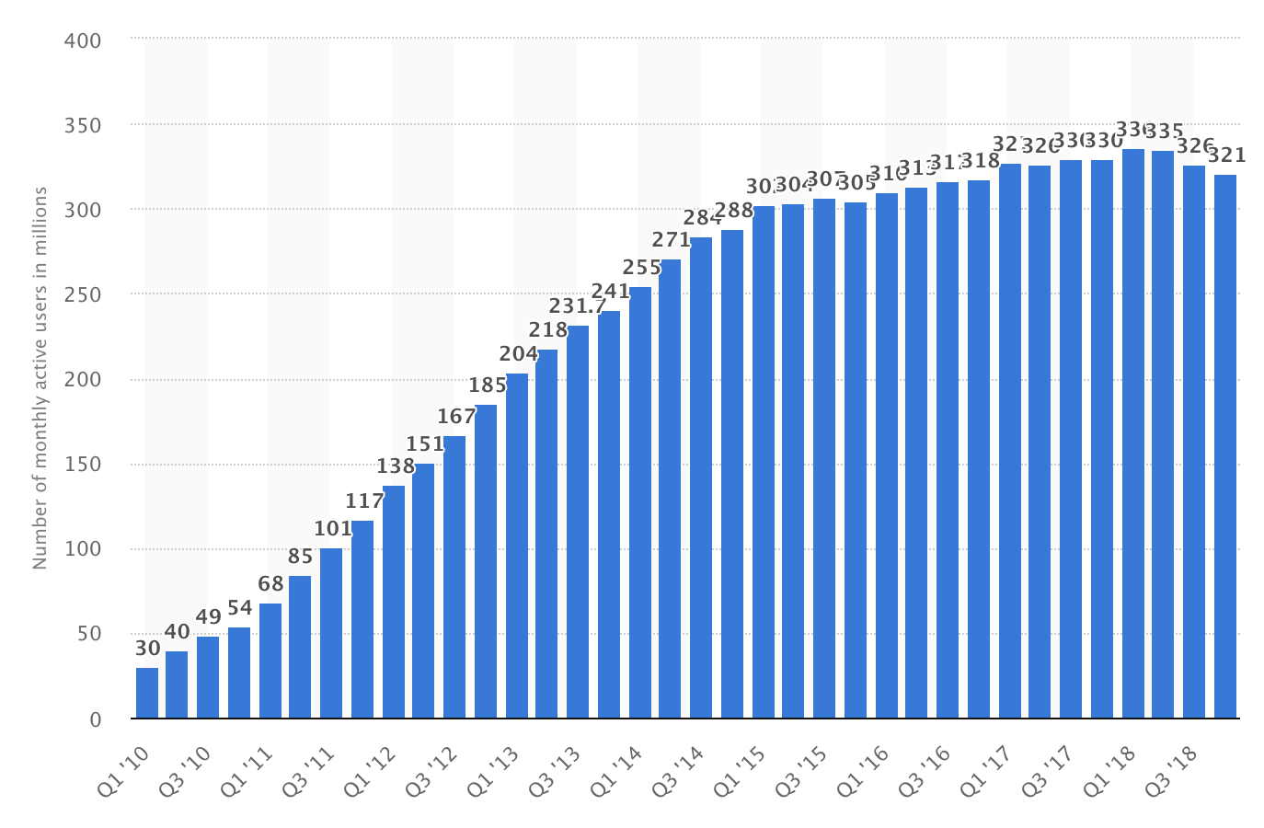

*Copyright 2019 Statista*

In terms of advertising revenue, the company continues to see positive growth year-over-year, with sales in 2018 rising to $3.9B, up from $3.2B in 2017. The advertising tools group has worked hard to make the site useful for marketers, providing not only targeted user search but also powerful analytics and dashboards, giving marketers greater insight into engagement with their published content.

*Figure 3 – Advertising revenue*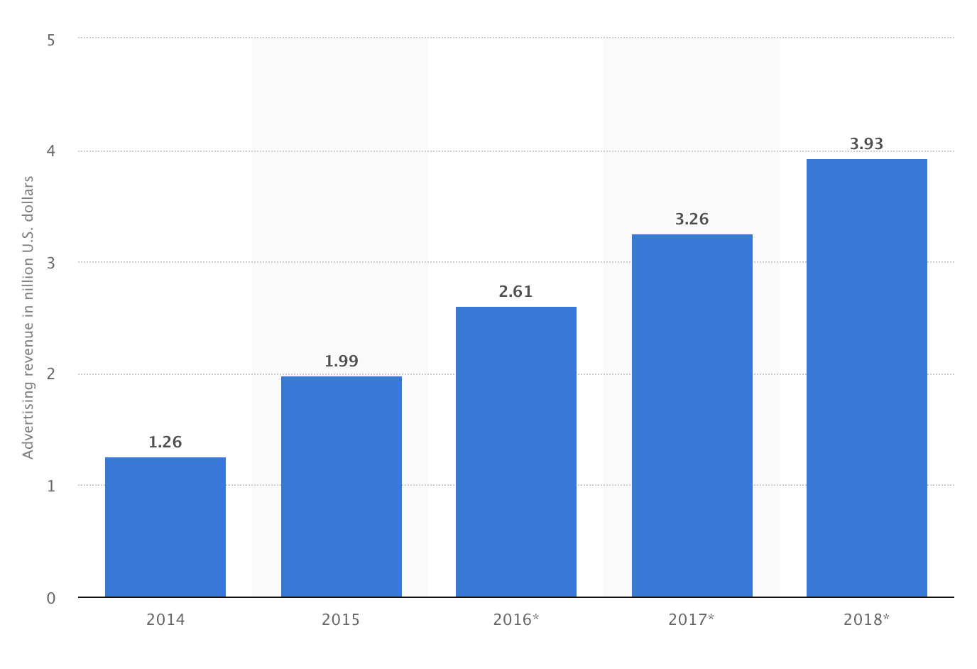

*Copyright 2019 Statista*

### Product Development

Over the last year, the product team has worked on improving the end user experience by making content stream management simpler, and by giving users more control over the type of content they see in their home feeds. Additionally, the team has worked to give premium publishers more content options, including streaming video episodes of popular shows in the U.S., Japan, Brazil, and the U.K. The Moments feature (topics and stories) now includes expanded coverage of sports, entertainment, news, and elections.

The Twitter for Enterprise project will be the biggest investment taken in the history of the company. Twitter will rely on its home-grown expertise in running custom data centers by building a version of its user experience software and distributed architecture aimed at large enterprises. The product will allow companies to provide Twitter-like services to their employees, including individual and group chat capabilities, the ability to share content like text, images, videos, and files, and also the ability to stream audio and video on internal networks.

The base services and infrastructure will be provided on a license basis with the possibility for additional fees through add-on services, long-term support, scale-out needs, and upgrades. The rollout of the service is targeted for Q4 2020 with $250M invested. By 2024, it is expected that the enterprise business will account for 10% of the company’s revenue. The team also expects adoption in the enterprise to drive a carryover effect in account signups for the public, ad-driven service as more and more customers become comfortable using the private service at work and desire to connect with friends and family outside of work using the same service.

The team believes the private service is needed to counter threats posed by Slack, Facebook Workplace, and Microsoft Teams. Facebook Messenger, WhatsApp, Skype and Zoom are also seen as potential threats that could be countered by offering this service.

Lastly, the team shared a slide of a Business Model Canvas outlining the new service.

### Technology Changes

Despite the benefit to enterprise customers that the private service creates, there are some concerns over the high cost to run the service, both in terms of infrastructure required and the amount of staff needed to keep the service running, not to mention the business unit that will be needed to meet the unique needs of each client. There are a couple ways that costs might be reduced: re-architecture, and integration with the existing public Twitter service.

First, the cost to run the current architecture of the proposed private service, based on Twitter’s public service, accounts for 60% of the licensing fee. The CIO points out that there are a range of technology options that enable the possibility for new architectures, including new platforms offered by the major cloud providers, and paradigms like Function-as-a-Service, aka “serverless,” which could greatly reduce the need for both dedicated hardware and the staff required by Twitter and its enterprise customers to monitor and administer the service. The head of product points out that the product and systems teams have just completed a major re-architecture of the existing public Twitter product and they expect the new enterprise service to take advantage of some of the new systems. However, a complete re-architecture has been discussed before, including the use of serverless, and the product teams have determined the effort would require a complete rewrite of several key systems that are core to Twitter’s existing functionality. The CEO also chimes in to say that a re-architecture would undermine the intellectual property already developed in Twitter’s existing services. The CMO and head of sales add that changing the service architecture at this point would create a marketing nightmare at a time when they are trying to promote Twitter’s stability and unique technology advantages of their private cloud product while also launching new efforts in developing markets.

The head of product also points out that, early in the discussions for the enterprise product, they inquired about simply integrating new features into the existing public service which could be enabled for private customers, but this was seen as a potential barrier to growth for the public service when other features were deemed to have higher priority. Despite this, everyone agrees the potential savings recouped by not building a separate, custom service could be substantial.

### Strategy

The head of strategy now talks about the future direction for the company. He reiterates that their overall goal is to build on the success they’ve had while keeping an eye on the future.

In recent meetings the strategic team have discussed the strengths of the company, the weaknesses in the existing product line, the potential opportunities in global markets, and future threats from companies like Facebook and Slack. The team believes these meetings had tremendous value and resulted in a number of promising opportunities for the company going forward. The options were presented to the wider company management team, priorities were identified, and the final decisions were approved by the CEO.

*Figure 4 – Company priorities*

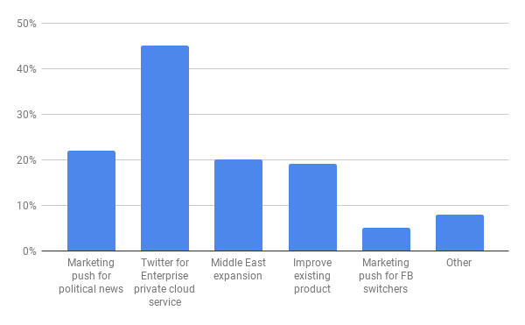

The focus and priorities of the company are:

* Build Twitter for Enterprise private/hybrid cloud product
* Marketing push and product enhancements to support engagement in the next presidential election
* Expansion of product into global markets, especially the Middle East region
* Increasing development of existing product in order to support content sharing and social network needs of customers
* Undertake a significant marketing campaign to take market share away from Facebook by targeting users who have considered getting off of that service

### 

### Finance

The CFO provides an overview of company performance with a basic P&L.

*Figure 5 – Profit and Loss Statement (P&L)*

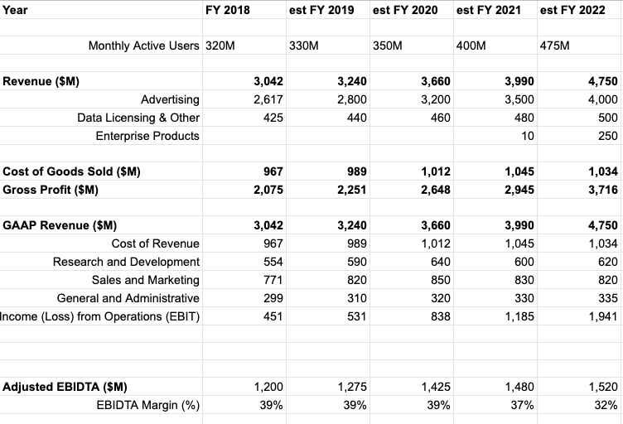

The CFO highlights the following:

* The company is profitable with revenue of more than $3B, a 25% YoY growth, and an EBITDA margin of 39%. The company has a healthy cash flow and reserves.
* There has been a recent re-organization in 2018 with digital combining with product development (previously under the CIO) but now run under the head of product. There has been investment in the product recently to meet demands to reduce abuse and increase engagement among existing users, as well as a push to acquire talent and technology through key hires and acquisitions.
* The product group will expand significantly over the next two years with the development of the enterprise product. Though the company is experiencing growth, the investment will have a material effect on EBITDA during 2020 and 2021. There will also be a major marketing campaign around the cloud service starting in 2020.
* The IT function now runs internal systems and data management. IT expects efficiency savings from moving portions of the core systems to cloud providers who are able to handle some of the workloads at a lower cost. This should reduce overall costs (both capex and opex) in 2019, with further reductions expected in 2020.
* The launch of a new product aimed at the Middle East region is planned for 2021. This will include a significant marketing drive, some additional admin (HR), finance, and IT costs, along with increased sales costs.

The CEO concludes the meeting and privately apologizes afterwards for the reaction of the CIO. She explains, “It has been difficult because of the changes. However, this organization is no longer a startup and some people have not found adjusting to this new world that easy.” You ask what she plans for the CIO and she comments, “Well, she did express some interest in setting up a new operation to capitalize on the opportunities in the gaming industry, but I think she knows that sometimes you just have to move on.”

### Your Task

You have a call with the executive board within the next hour. That’s how long you have to make your choices. Your first task is to determine whether the company is headed in the right direction. You should determine whether you agree with the priority order given in Figure 6. If not, write down what your priority order would be. If you decide to invoke “Other”, then write down a brief description of what that is. Once you’ve decided your priority order, then your next task is to determine what you’re going to say to the executive board.

(see priorities on the next page)

*Figure 6 – Your Priorities*

